ISTANBUL TECHNICAL UNIVERSITY
PROJECT DESIGN AND MANAGEMENT
TERM PROJECT GUIDELINES
2026-2027 FALL

Project Team: 7-8 Students

Term Project will include a detailed project plan preparation on a sustainable entrepreneurial business or social project idea generated by students. Each project must be related and contributing to a SUSTAINABLE DEVELEOPMENT GOAL (SDGs).

Please see “Tools for Project Design and Management.pdf” at Class Files/Ninova for the tools (Gantt Chart, business canvas, organizational chart etc) you need to use to complete your project. At this file, programs, tutorials and websites related to project management that you can use throughout the semester and in your term project are given with links.

Please note that AI use checks will be conducted for the submitted projects. In addition to their project reports, all groups are required to sign and submit the “ISL 443E AI Conduct and Declaration” document available on Ninova.

- Project Progress Report
- Explain your project proposal; Problem definition, Solution Options, Background of the problem, Benchmark with current solutions, context (Industry, market, company, process, system etc.) analysis (add a Business Model Canvas)
2. Define the organizational structure of project that is belong to main organization, and explain your reasons to choose this structure.
3. Determine the project team, the members’ appellations and professional qualifications.
4. Display the estimated-brief Work Breakdown Structure of the project. (Including Resources, Predecessors, Explanations)
5. Action plan of the project.
6. Display the Responsibility Chart of project.
7. Display cost baseline and budget of the project
8. Depending on the costs Feasibility of the Project: Calculate the appraised investment costs, earnings, and evaluate them with profitability measures (for example; return on investment, net present value).
9. Schedule the project network (determination of critical path) and define the allocation of resources (information about cash flow of each activity for each week
- Project Final Report
1. Build a Project Charter : Explain the mission of project; project’s turning points (milestones, control points); requirements (facility, equipment, material, labor, etc); time, cost and performance limits; political decisions on administrative and technical subjects of Project, assumptions, limitations
2. Define the organizational structure of project, explain your reasons to choose this structure. (Define the main organization structure which the project team belongs to (if any)
3. Determine the project team; define project team member roles and responsibilities, qualifications
4. Display the Work Breakdown Structure of the project.
5. Action plan of the project.
6. Assign Team to Resources, Create Responsibility Matrix
7. Display cost baseline and budget of the project
8. Discuss the investment in terms of its feasibility : Economic, operational, technical and legal – Adapt a Scoring Model
9. Schedule the project network (determination of critical path) and define the allocation of resources (information about cash flow of each activity for each week
(For the Works 1-9, YOU MUST REVIEW AND ITERATE YOUR PROGRESS REPORT CONTENT IF NEEDED- Strongly recommended to improve your progress report content )
10. Define the project’s life cycle and briefly explain which main tasks could be made in each step of the cycle.
11. Define Resource Loading and Allocation, Levelling
12. Provide the Stakeholders Analysis
13 Provide the Risk Management plan
14. Communication Plan
15. Other Procurement Quality plans

Important Note for project planning:
- In new business projects, providing finance and funding resources is critical. Please provide a Task (Group of Work Packages) providing capital for your project.
- Market Research / Requirements analysis must also be included in the project plan as a Task.

SAMPLE TEMPLATES ARE GIVEN IN THE FOLLOWİNG PAGES..
AS CAN BE SEEN FROM THESE SAMPLES, YOU CAN USE THE TEMPLATES THAT ARE AVALIABLE IN MS PROJECT OR OTHER PROJECT PROGRAMMES (Open Project, etc.) IF YOU WANT TO USE MANUAL TABLES; YOU CAN USE THE OTHER SAMPLES GIVEN.

Project Planning Form | Project Owner
Project Planning Form | Project Contractor
Project Planning Form | Project Duration (Month/week/year/day)
Project Planning Form | Project Sponsor
1. PROJECT TYPE*
1. Technical Project
2. Service Project
3. Business Idea Realization 
……...

2. NAME OF THE PROJECT
“ ………………………. ”

3.PROJECT MANAGER
Title | Name | Affiliation | Profession | Contact number | e-mail | Signature

4. AIMS, OBJECTIVES AND CAUSES FOR THE PROJECT

5. Project Explanation and Assumptions

6. TIME OBJECTIVES of THE PROJECT
START DATE: MANAGEMENT STARTING DATE:
COMPLETION DATE:
7.Project Responsibles (*)
Title | Name Surnameı | Task and Responsibility |  |  | Contact  Number | e-mail | Signature

8. BUDGET ESTIMATION (*) (TL)
DISTRIBUTION OF BUDGET BY EXPENSE ITEMS
  - Human Resources costs
  - Material and equipment costs
  - General expenses

TOTAL

9. APPROVAL (shall be filled by Project Owner, Project Manager, Project Sponsor.)
Title Name Surname Signature Date
………………………. …………………………..

APPENDIX

10. ORGANIZATION STRUCTURE OF THE PROJECT , STAKEHOLDERS ANALYSIS (Samples in Appendix A)

11. BASIC Work Breakdown Structure of the Project, Resource Planning (Detailed WBS, assignment of Workforce, equipment and material in WBS, WBS Dictionary – Sample in Appendix B)

12. MILESTONES of the Project (in accordance with WBS); Role and responsibility assignments and entitlements (Sample in Appendix C)

13. TIME SCHEDULE of the Project (in accordance with WBS) (Gannt Chart, CPM and PERT Analyses Samples in Appendix D)

14. BUDGETING AND COST PLAN of the project (In accordance with WBS, Time Schedule) (Details in Appendix E –Cash Flow Table, NPV, IRR)

15. RISK PLAN of the Project (Risk Distribution Structure, Risk List, Probability Impact Matrix, samples given in APPENDIX F)

16. COMMUNICATION PLAN of the project (Reporting and documentation system, samples in Appendix G)

17. PROCUREMENT PLAN of the project and Contract Management Plan (Samples in Appendix H)

18. QUALITY PLAN of the project (samples in Appendix I)
------------------------------------------------------------------------------------------------------------------------------------
NOTE: In the end of the project following questions must be answered within the above mentioned sections:

1. Why are we doing this project? Why is it good for our company?
Focus on value, benefit, and purpose. Project scope management.
2. What are we making? Define the scope of the project. Project scope
management.
3. How will we make it? Project scope management.
4. When will we do it? Project time management.
5. How much time will it take? Project time management.
6. How much money will it cost? Project cost management.
7. What makes it good? Project quality management.
8. How can we make sure it gets done? Project risk management.
9. What could go wrong? Project risk management.
10. Who will do it? Project human resources management.
11. How will we keep in touch and stay on the same page? Project communications
management.
12. What do we need? How will we get it? Project procurement management.
13. How do we keep it all together? What do we do if things change in the
middle? Project integration management.
14.Whether we should do the project or cancel it? If things go wrong during
a project, we can say, “No, we should cancel this project.” We
should always keep in mind the possibility of cancellation. If we know
the project could be canceled, we’ll be sure to get it done right.

Appendix A. 1) Organization Chart of the Project (Detailed figures)
Name Surname Profession Department/Affiliation
1. Project Manager
2. Project Manager Assistants
3. Project Auditor
4. ...........
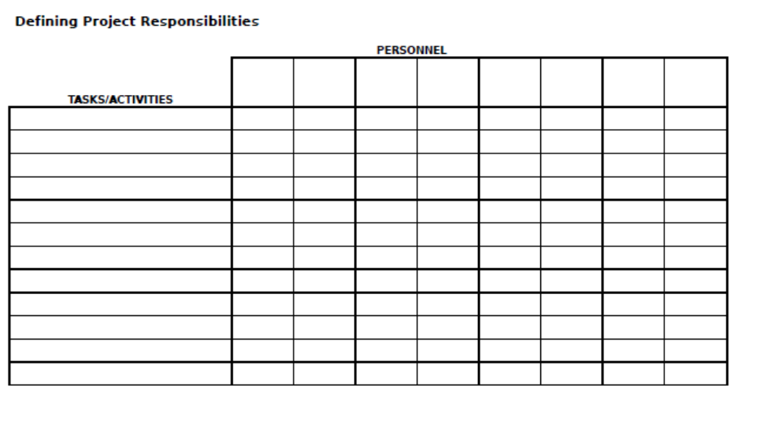
Example
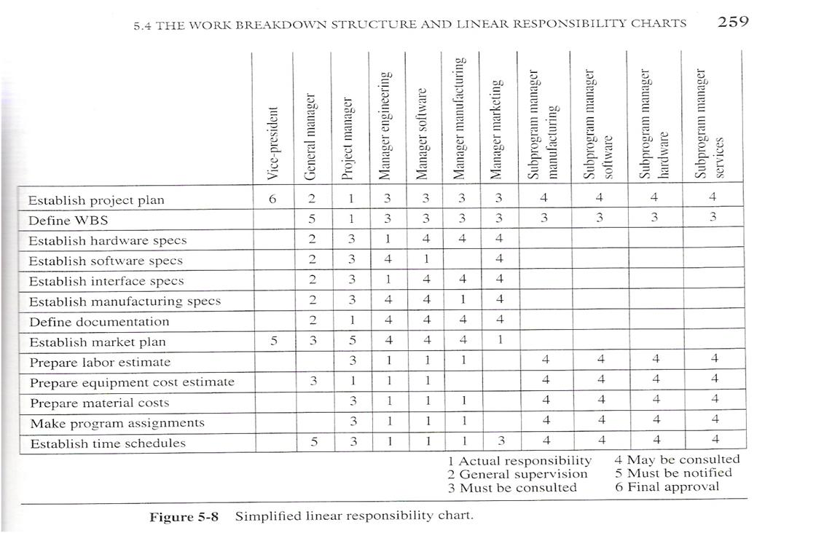

2) Define the Stakeholders (Critical for Entrepreneurial Projects) - PLEASE PROVIDE LINKS BETWEEN STAKEHOLDERS ANALYSIS AND RISK MANAGEMENT PLAN and COMMUNICATION PLAN

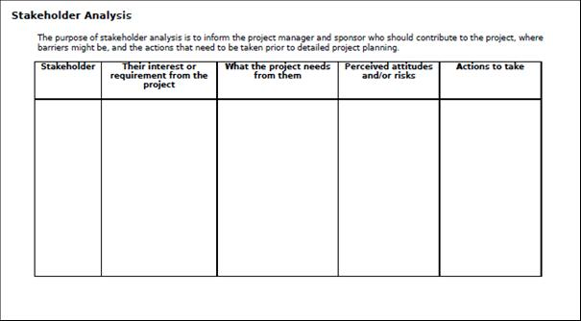

Examples:
      - Stakeholders and Assignments of Project Team per Stakeholder

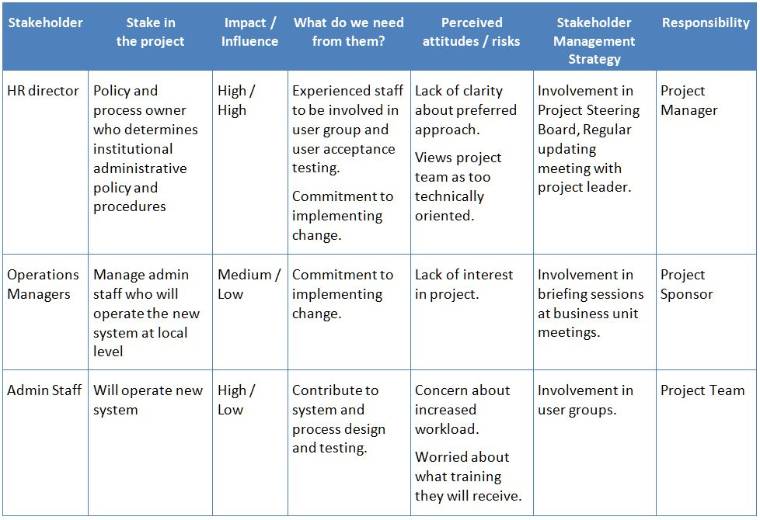

      - Stake Holder Impact Analysis
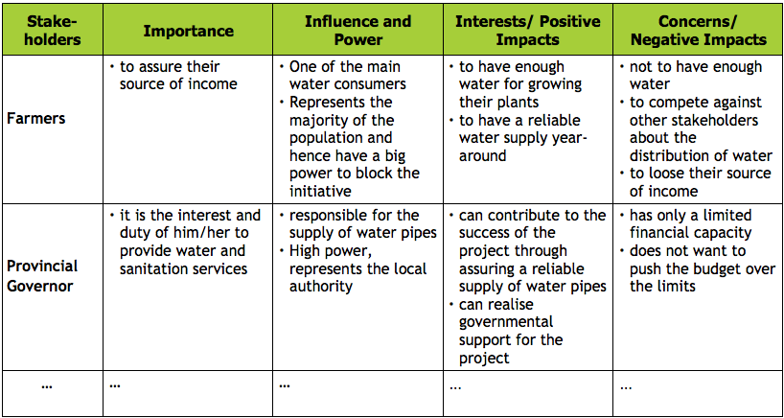
Appendix B. - Basic Work Breakdown Structure (WBS) of the project
- Work assignment structure of the project
- Resource Planning of the project
(Detailed WBS and Resource allocation chart is as follows.
WBS dictionary is attached)

Activity List
NO | Name of the activity | # Days | Starting date | Completion Date | Contact | Responsible | Deliverable | Milestone
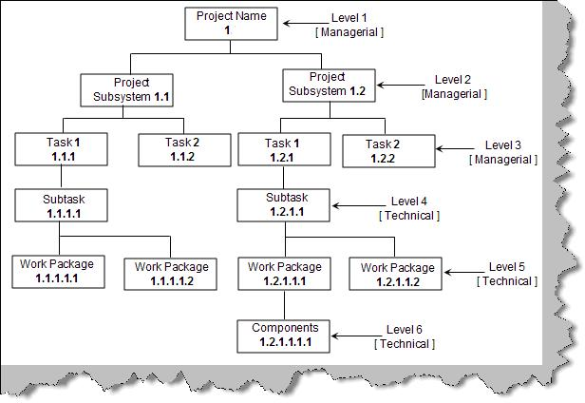

Examples:
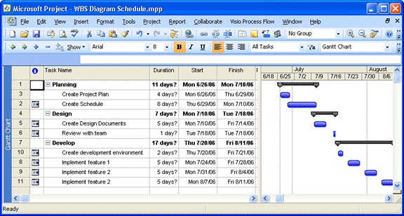

Appendix C. MILESTONES of the project (In accordance with WBS)
- Detailed Responsiblity and Role List
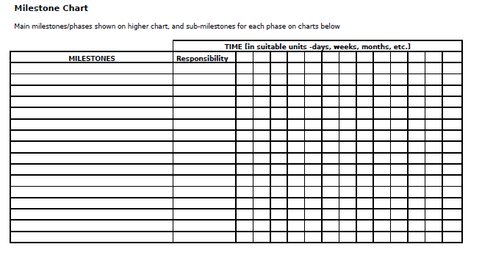
Milestones List (alternative)
Deliverable | Approval  Criteria | Delivery Date | RelatedWork from WBS | Responsible
Examples:
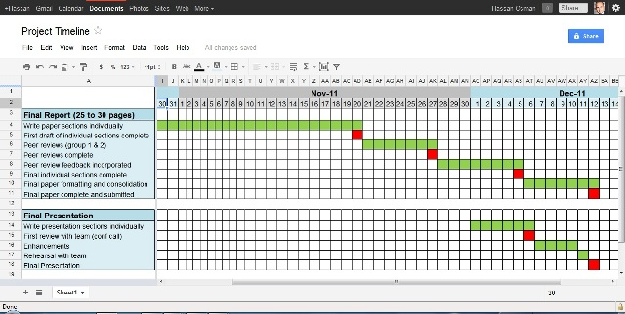
- Red cells are milestones
Appendix D. Time Schedule of the Project (In accordance with WBS)
GANNT Chart
CPM Analysis
PERT Analysis
Starting Date Completion Date
1.. FIRST MAIN WORK
2. SECOND MAIN WORK
3. ……..
Examples:

- Time line and Critical Path on Gannt

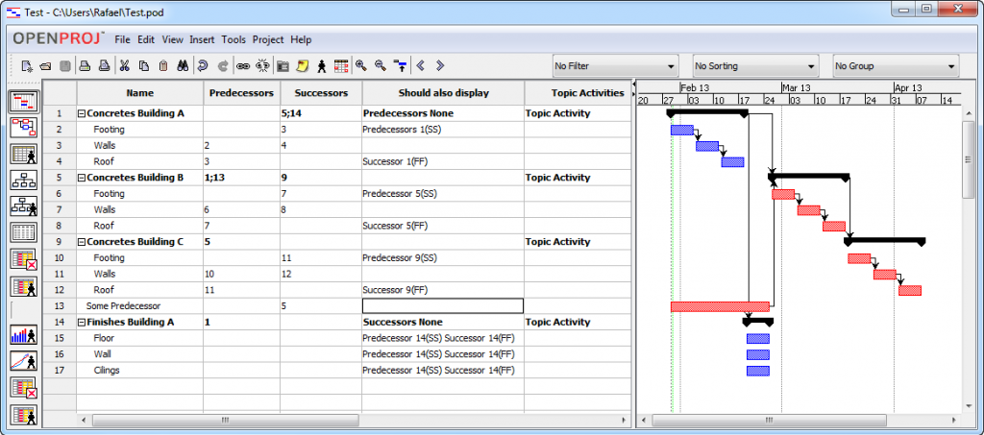
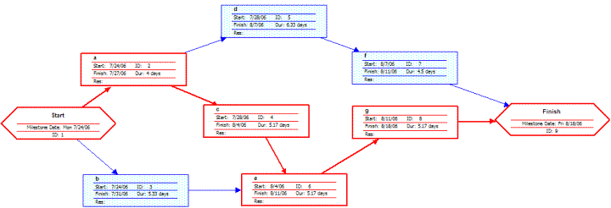
- Red tasks are on critical path
- Critical Path

Appendix E COST PLAN OF THE PROJECT (In accordance with WBS, Time Schedule and Budget) CASH FLOWS TABLE, NPV and IRR calculations.)

Cost Estimate for Completion
Cost Items | Explanation | Procurement/  purchasing | Total Cost | Responsible  For Cost  Estimate | Responsible  For Procurement
Travel costs
Contacting
Hiring
Insurance Payment
Advertisements

ALTERNATIVE TABLE

Nr. | Activity | Responsible | Unit Price (UP)  (TL) | Budgeted  Time (BT)Hour/day..) | Total Cost  (UP*BT)

Examples:
- Costs on Gannt (B)
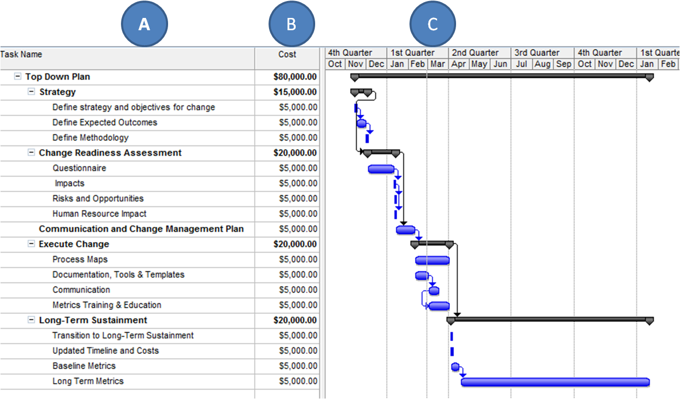

- Cost Baseline by Month

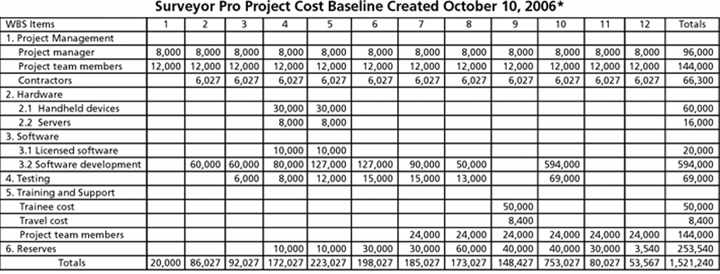

- Cost analysis (Earned Value Analysis)
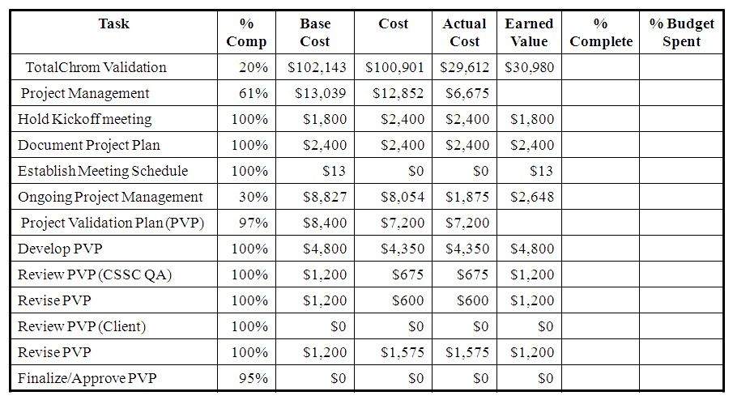
Appendix F. Risk Plan of the Project (Risk Distribution Structure, Risk list and Possibility List, Possibility Impact Matrix) – In accordance with the WBS -

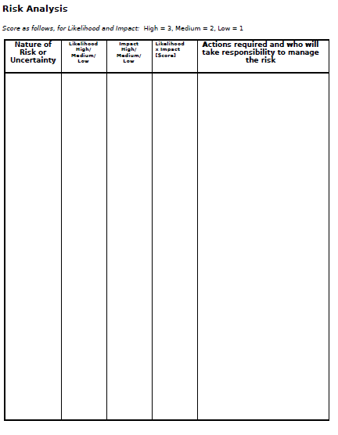

Risk Category/Event | Possibility  (P) % | Importance  (I) | Expected  Impact (P)*(I) | Preventive  Actions | Corrective  Actions

Examples:
- Risk Plan and Actions
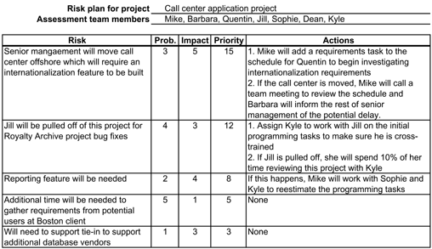

- Risk Mitigation Plan
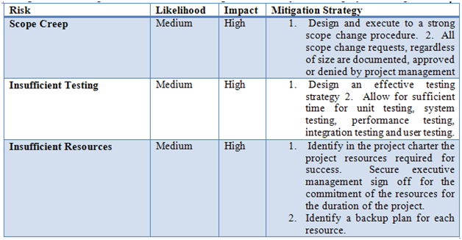
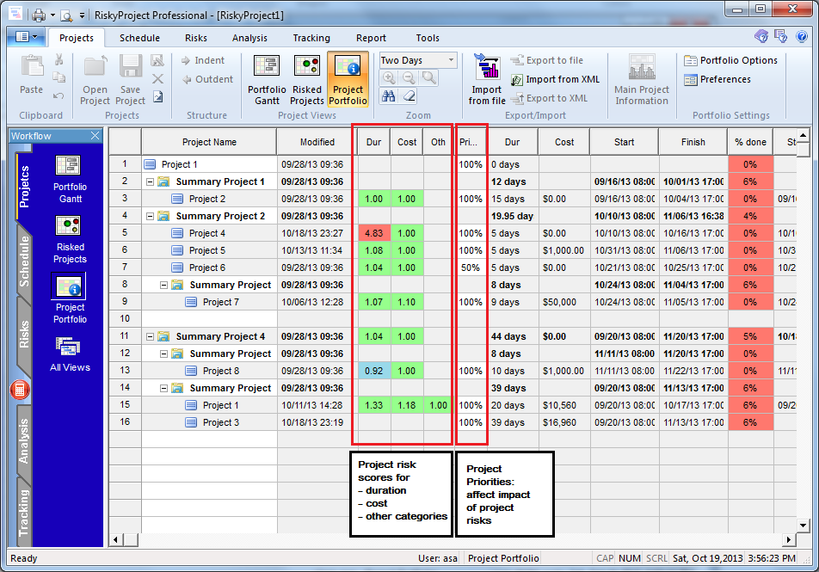
- RiskyProjectProfessional Screen (This is an Add-in application of MS Project. Not reuired, but can provide insights on applying Risk Management in Projects)
Appendix G. Communication Plan of the Project (Reportings, Meetings and Documentation system) - PLEASE DEPEND ON COMMUNICATION PLAN ON THE REVIEW AND APPROVAL OF 1. MILESTONES, 2. RISKS

 | Name of the report | Resource | Period | Responsible | Approval by | Related Deliverables
Topic (Tasks, milestones, reviews etc.)

Examples:

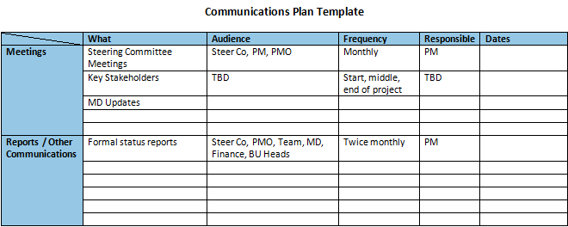
- Sample Template

- Sample Communication Plan (Linked to milestones and also agenda included)



